**Cedar Elementary School**

ESAIL Walk-through Implementation Analysis

Michelle Amend

Walk-through date: February 27, 2014

Introduction:

Dear Ben, Sarah, Rachel & Sam,

Thank you for coordinating a wonderful site visit to Cedar Elementary School. It was rewarding to see how the Cedar teachers have taken on the Partnerships in Comprehensive Literacy Model. Ben, it was especially uplifting to see how engaged you were in the process, eager to build your own professional knowledge in literacy. You are truly an instructional leader at heart and Cedar is fortunate to have you as their principal.

Under your leadership Ben, and with the support of Sarah, Rachel, Sam, and teachers, your school is truly becoming a model for how a comprehensive literacy design should look. The PCL model is a decision making model based on strong understanding of the learning process.

The intention of this particular PCL implementation analysis was to ascertain how it is going with the implementation of the components you have focused on and to make recommendations for next steps that will help shape your future goal planning. To that end, I looked to celebrate the current accomplishments and identify trends that would provide insights for professional development, grade level planning, opportunities for peer coaching and shared leadership. The heartbeat of this type of analysis might be likened to flying into an airport when you’re close enough to the ground, yet high enough above the ground that you can see the traffic patterns of the cars and highways as they feed into the city. Please know that it was truly exciting to see from a bird’s eye view that the framework of the Comprehensive Literacy Model is in place. Rest assured that your investment in the Comprehensive Literacy Model is built on solid footing.

The specific focus of the site visit was intentionally similar in all schools and was two-fold. Under the direction of Linda Dorn and Carla Soffos, I determined two broad categories that are relevant and critical right now in preparing students for 21st century College and careers. The first lens focused on procedural structures, routines and curricular materials. The second lens focused on how to use the curricular materials to achieve Common Core State Standards. The second focus, therefore, attended to the rigor of the curriculum. The analysis of current practice juxtaposed with the goals for where we want to be, will provide Cedar with the necessary information for determining and developing next steps. After the school analysis within each of the ESAIL criteria, this report will conclude with a summation of the findings and personal reflections for consideration as you move forward to define your next steps.

Summary of Findings

The Summary of Findings is organized by the ESAIL criteria targeted for the walk-through. Under each criterion, the report will identify:

* Criterion description taken directly from the ESAIL
* Observable evidence from the walk-through
* Vision for where we want to be
* Next Steps: suggested focus

The first two bullets, criterion description and observable evidence, will be obvious in the report and require no further explanation. However, a description for the next two bullets, where we want to be and next steps, is necessary in order to help the reader gain the greatest understanding and use of the information shared.

Where We Want To Be – Understanding how to read this section

Going from current reality to recognizable growth is achieved through setting short and long-term goals, which are further prioritized into manageable action steps. With that understanding in mind, the proper lens from which to read the “Where We Want To Be” sections of this document is to know that restraint must be exercised in selecting the next high leverage focus for school improvement. That means Cedar will need to show prudence in choosing one or two teaching practices from the number of suggestions offered throughout this document. Numerable suggestions are offered to provide you with a complete picture of possibilities. In no way is it the intention of this external observer to suggest that Cedar attend to each of these items. Again, the inclusion of the goals is strictly for background knowledge to provide the district administrators and coaches with depth and breadth of information from which to determine next steps for Cedar. In sum, much will be offered, yet few should be chosen (at this time).

Next Steps – Understanding how to read this section

In the “Next Steps” section under each ESAIL category a recommended action item is offered, from an external viewpoint as being the highest leverage focus for the said category. In other words, the “Where We Want To Be” items will be synthesized or prioritized into one or two key ideas. Yet, it will still be important to note that an overall decision must be made to select only one or two action goals out of the entire report to ensure high quality implementation and transformation.

ESAIL Criterion 1: Creates a Literate Environment

Under Criterion 1, Cedar teachers have much to be proud of in terms of their professionalism and integrity to implementing the Comprehensive Literacy Model. Their instructional practices are focused. Their teaching objectives are clear. Their rooms are uncluttered and organized. Their relationships with students are genuine and thoughtful. Cedar is a community of learners with high expectations for teachers and students.

**ESAIL Criterion 1: Creates a Literate Environment**

Teachers create a literate environment by providing a wide variety of reading experiences, including rich and diverse opportunities for students to read, discuss, and write texts across the curriculum. Students’ learning at various stages in the reading and writing process is celebrated and displayed on walls within and outside classrooms. Classrooms are arranged to promote whole and small group problem-solving discussions. Inquiry-based learning is evident, including relevant and purposeful talk. Respectful talk and attitudes are promoted and used among students, and students’ questions are valued by providing additional opportunities for clarifying and seeking information through research.

Context for understanding this category is helpful. For example, ESAIL 1.1 identifies as evidence of a literate environment, the display of reading responses through writing on classroom walls, in hallways, and in students’ reading logs. This is because reading responses through writing addresses comprehension. To teach for comprehension is to set up opportunities for students to engage in listening to and responding to complex text (at or above grade level) by talking, writing and reading with supportive scaffolds. Listening to, talking about, and writing about text at levels higher than they can read builds background knowledge that positively impacts reading achievement. Current research findings stress the importance of incorporating explicit vocabulary instruction as part of the comprehension focus. James Zull, professor of biochemistry and biology at Case Western Reserve University in Cleveland, Ohio is a practicing scientist who studied teaching and the brain. He found that, for the brain to complete the learning cycle, learners must engage in "acting" on their learning. He calls this "active testing." This happens in school mostly through talking or writing. Therefore, we want to provide opportunities for students to talk and write as modes of completing the learning cycle process and thus increasing their comprehending skills. This goes beyond the turn and talk opportunities in guided practice to include extended opportunities to talk and think and write about thinking.

With that understanding, the following examples offer evidence of the level of thinking observed either through Thoughtful Log prompts, anchor chart prompts, mini-lesson dialogue, small group dialogue or conferencing. Hess’ Cognitive Rigor Matrix (See Appendix B & Smarter Balanced Assessments: Applying Webb’s Depth-of-Knowledge ‘DOK’ Levels to Bloom’s Cognitive Process Dimensions) was used here for analysis. In the Vision For Where We Want To Be section, staff development ideas will be shared.

Examples of Observable Evidence from Walk-through

ESAIL 1.2 focuses on writing taught as a process and displayed in the classrooms and hallways as a mark of a literate environment. Writing is clearly taught as a process at Cedar. In kindergarten however, writing appeared to be more formulaic than authentic which limits children’s growth as writers as well as sends the message that writing is about only producing controlled knowledge. A book study of chapter one in *Scaffolding Young Writers* (Dorn & Soffos, 2001) would strengthen the kindergarten teachers’ understanding about early writing development. Though, this concern did not surface in first grade the volume of writing in the first grade folders tended to be shorter than what would be expected in first grade at this time of year.

**K –Thinking Level: Bloom’s Taxonomy- Remember/Webb’s DOK 1- Recall & Reproduction-** Classroom example, “What do we know about leprechauns?”

**K-Thinking Level: Bloom’s Taxonomy- Apply/Webb’s DOK 3- Strategic Thinking/Reasoning- Apply a concept in a new context-** Classroom example, in interactive writing lesson students applied knowledge of concepts about print to writing.

**Gr. 1- Thinking Level: Bloom’s Taxonomy-Understand/Webb’s DOK 3- Strategic Reasoning-** Classroom example, “How do you think these animals can see or get around in the dark?” “Why might an animal only come out at night?”

**Gr. 1- Thinking Level: Bloom’s Taxonomy-Remember/Webb’s DOK 1-Recall & Reproduction-** Classroom example, “Who remembers the first step in the writing process? Who can tell me what revise means?”

**Gr.2- Thinking Level: Bloom’s Taxonomy- Apply/Webb’s DOK 3- Apply a concept in a new context-** Very strong classroom example, “In Social Studies we identified good character traits of a president. Now, we’ll listen to our story again, *Wimberley Worried*, and we’ll use the graphic organizer to put down words to describe his character traits.”

**Gr.2- Thinking Level: Bloom’s Taxonomy- Understand/Webb’s DOK 2- Skills & Concepts-** Classroom example found in an anchor chart with column on left identifying mentor texts and column on the right providing examples of various types of dedication pages found in books.

**Gr. 3- Thinking Level: Bloom’s Taxonomy- Create/Webb’s DOK 3- Strategic Thinking/Reasoning-Synthesize information within one source-& Bloom’s-Analyze/DOK 3- Analyze or interpret author’s craft-** Very strong classroom example, “How is the character a symbol of hope?”

**Gr.3- Thinking Level: Bloom’s Taxonomy- Understand/Webb’s DOK 3-Strategic Thinking/Reasoning-** Classroom example, “What lesson does this story teach us about homelessness, poverty and hope? Give evidence.”

**Gr.4- Thinking Level: Bloom’s Taxonomy- Create/Webb’s DOK 3-Strategic Thinking/Reasoning- Synthesize-** Classroom example: mini-lesson/anchor chart- Synthesizing is when you take what you already know and what you learn from reading to create a new understanding- modeled example with informational article about a new type of car.

**Gr.4- Thinking Level: Bloom’s Taxonomy-Understand/Webb’s DOK 2-Skills & Concepts-** Classroom example, “Why do you think the title of the article is *Doctor Bugs?*

**Gr. 5- Thinking Level: Bloom’s Taxonomy-Apply/Webb/s DOK 3- Strategic Thinking/Reasoning-** Classroom example was a mini-lesson applying the internal consistency of text organization and structure to composing a full composition. Students were learning how to narrow the focus into subtopics for a nonfiction piece.

Examples of Observable Evidence from Walk-through

* Co-constructed anchor charts demonstrate explicit teaching of writing process.
* Writing Journals/folders provide evidence of all parts of the writing process.
* Walk-through observational notes captured classroom instruction of mini-lessons, small group instruction, partner work, and independent work demonstrating attention to writing process.
* Sign up sheets were posted for conferencing with the teacher.

ESAIL 1.3 highlights the need for diverse reading materials to be enjoyed, discussed and analyzed across the curriculum. Under this particular criterion, as a procedural structure we are looking to see if there is a broad range of text types to provide students with opportunities that consolidate and challenge their processing systems. Does the classroom library have within each category, single copies of: easy text, instructional text and complex text? Complex text refers to literary fiction and nonfiction text written by well-known authors such as those highlighted as exemplars in the CCSS and those for which a level cannot be determined. (See CCSS p. 31, triangulation for matching books to readers.) In the classroom library tubs we should see texts that are culturally and linguistically relevant rather than culturally and linguistically neutral (Hollie, 2011). Then, at the level of curricular rigor for ESAIL 1.3 we are looking to see how complex text is analyzed and revisited across the workshops. The teaching component must be rigorous to achieve CCSS. Rigorous teaching should be reflected in the rigor of the language charts. Note: there is a difference between complex text and hard text. Students can read complex text if the teacher spends time with close reading, revisiting the text for multiple teaching points, building of background knowledge and carefully choosing engaging texts that are meaningful and relevant to the students. Evidence of rigorous teaching in this area would be reflected in language charts and logs that show that the mentor texts have been “de-constructed” in several ways (vocabulary, grammar, text structure, genre characteristics, relationships such as how setting does or does not influence plot, character behaviors, etc.) The enjoyment part would be evidenced by entries that represent reactions to the story at a personal level without in-depth analysis and/or in anchor charts that might suggest for example: fun words we found…

Examples of Observable Evidence from Walk-through

* Current mentor texts are displayed.
* Anchor charts show analysis
* Several anchor charts across the grades and some log entries show that mentor texts have been deconstructed and revisited to build deeper webs of conceptual understanding.

ESAIL 1.4 pinpoints the importance of co-constructed anchor charts, which embrace student language, and are displayed on walls and in students’ notebooks. Language charts are metacognitive tools to deepen comprehension. Cedar, as well as all Houston’s elementary schools, demonstrates an exemplary understanding of the theory behind language (anchor) charts as instructional scaffolds for student learning. There were several examples of procedural, instructional and assessment co-constructed anchor charts as nonverbal scaffolds to lift comprehension. The anchor (language) charts illustrate explicit teaching with clear objectives. The self-regulated behaviors of the students give testimony to the expectation that the charts are visual reminders of what it looks, sounds and feels like to be a learner at Cedar Elementary School.

For ESAIL criterion 1.4, in addition to looking for the basic understanding that language (anchor) charts are used as scaffolds for learning, we need to examine the relationship between the anchor charts and grade level standards in CCSS. Throughout the grades there was evidence of this alignment as illustrated through the following examples:

Examples of Observable Evidence from Walk-through

**K- CCSS Reading Standard, Foundational Skills: RFK.1a- follow words from left to right, top to bottom, and page-by-page;** Classroom example, teacher modeled through interactive writing piece.  **RFK.2b- segment and blend words;** Classroom guided reading example: “Does hat start with ‘h’?” **RFK.3c: Read common high-frequency words (HFW) by sight (e.g. the, of to, you, she, does.)** Classroom example, mini-lesson/guided practice locating HFW in a mentor text.

**Gr. 1-CCSS Writing Standard W1.5: With guidance and support from adults, focus on a topic, respond to questions and suggestions from peers, and add details to strengthen writing as needed.** Classroom example- writing mini-lesson modeling how to write 3 details to support opinion piece that March will come in like a lion or a lamb. **RI1.5- Know and use various text features…** Classroom example, “What does a heading in non-fiction text do or tell us about?”

**Gr. 2- CCSS Writing Standard W2.3: …use temporal words to signal event order…** Classroom example: mini-lesson on publishing opinion posters on “Why I Would Be a Good President” included a review of inclusion of transition words. **RL2.2: Recount stories, including fables and folktales from diverse cultures, and determine their central message, lesson, or moral.** Classroom example compared 2 versions of the 3 Billy Goats Gruff with a focus on expressive voice and intonation.

**Gr. 3- CCSS RL3.2: Recounts stories, including fables, folktales, and myths from diverse cultures: determine the central message, … and explain how it is conveyed through key details in the text.** Classroom example, students analyzed traits of a tall tale in previous lessons and applied them to a persuasive writing piece they created. **RL3.3: Describe characters in a story (e.g. their traits, motivations, or feelings) and explain how their actions contribute to the sequence of events.** Classroom example, “I want to stretch Mitchell’s thinking. What challenges might face him? The book didn’t say.”

**Gr. 4- CCSS Reading Informational Standards RI4.2- Determine the main idea of a text and explain how it is supported by key details; summarize the text.** Classroom example was evidence through a mini-lesson and anchor chart on determining importance in a non-fiction text.

**Gr.5-CCSS RI5.8: Explain how an author uses reasons and evidence to support particular points in a text, identifying which reasons and evidence support which point(s).** Classroom example, mini-lesson on narrowing the focus of informational writing into subtopics with supporting details.

ESAIL 1.5 states that when tables, clusters of desks and/or areas are arranged for whole group, small group, and individual learning, collaborative learning and problem solving is promoted. Most of Cedar classrooms are ideal in their use of room arrangements to prioritize differentiated learning through large, and small group areas. Students in most classrooms are notably in charge of their learning.

ESAIL 1.6 centers more closely on problem solving as collaborative in pairs or groups and specifically on the need for student and teacher talk to be purposeful and goal directed. The idea here is that the physical structure of the room supports the learning theory of social construction of knowledge. In regard to rigor, our attention turns to the idea that we are looking for independence of the learner. Are the students in charge of their own learning? We should see evidence of this beginning in kindergarten. Differentiated learning and social construction of knowledge is evident in Cedar classrooms through turn and talk opportunities during whole group instruction, partner and collaborative small group work during guided practice and buddy work during independent work time. Furthermore, conversational moves are taught and adhered to in small group instruction with the teacher in order to focus communication and build chains of discourse that deepen comprehension. Finally, teachers are particularly mindful of conducting short mini-lessons for precise teaching and for maximizing student interaction time.

ESAIL 1.7 emphasizes that student engagement is directly related to and maintained by meaningfulness and relevance of the task. Relevance is established at Cedar through the instructional protocols, which identify learning targets, rationale, etc. with specific differentiated components for whole group, small group and independent learning contexts. Intentional teaching of all components of the workshop model contributes to student engagement. At Cedar, students in most classrooms were engaged. There were differing levels of productive independent work, with tasks overall being relevant. That is to say that, most students at all grade levels appeared engaged in their independent work. Independent work time is about building self-regulation skills, consolidating learning and working on fluency in all areas (writing, reading, talking).

ESAIL 1.8 links the literate environment to respectful talk and attitudes that are promoted and used among all learners. Cedar excels at ESAIL 1.8. Classrooms were calm and peaceful. Students interacted appropriately and respectfully with others. Teachers were superb role models through their interactions with students.

ESAIL 1.9 calls for teachers to promote elaborated discussions around specific learning goals and to demonstrate that they value student thinking and student discussion around thinking. Examples of accountable talk were seen in several learning contexts including whole group instruction, small group instruction and one to one conferencing. Students’ thinking was valued in every single classroom. A walk-through provides limited opportunity to witness deep level questioning. However, on Cedar’s walk-through some evidence was noted under previously shared criteria and the examples below are shared to illustrate the level prompting or questioning observed.

Examples of Observable Evidence from Walk-through

**Gr. 1 classroom example of a Bloom’s Taxonomy Cognitive Process Dimension at the level of Understanding and Webb’s Depth of Knowledge Level 2: Skills & Concepts: Summarize:** “Read this part here silently and then tell me in your own words what it says.”

**Gr. 3** **classroom example of a Bloom’s Taxonomy Cognitive Process Dimension at the level of Create and Webb’s Depth of Knowledge Level 2: Generate conjectures or hypotheses based on observations or prior knowledge and experience:** “What lesson does this story teach us about homelessness, poverty and hope? Give evidence. Now, what lesson did you learn?”

**Gr. 4** **classroom example of a Bloom’s Taxonomy Cognitive Process Dimension at the level of Create and Webb’s Depth of Knowledge Level 3 synthesize information within one source of text:** “Let’s revisit our anchor chart on synthesizing- we take what we already know plus what we’ve learned from the reading to create a new understanding. We’ll revisit the article, ‘Your Car Will Drive You’. What do we already know? What do we know about safety?...”

ESAIL 1.10 looks for the classroom environment to be conducive to inquiry-based learning and for students to be engaged in constructive interactions around purposeful literacy events. There was evidence of attention to inquiry in the Cedar classrooms, such as with research units, and yet this would be an area for future growth. See the last bullet under “Where We Want To Be” for more information.

Where We Want To Be in relation to ESAIL 1

* Consistent K-5 use and understanding of the importance of using the logs for writing about reading and writing about thinking that has come from elaborated discussions around complex text at their listening comprehension level as well as what is currently being done with the books they read at their instructional level. Here we are looking to see how written language in complex text is used to increase comprehension. We aim to help students in all grades understand the richness of the language used in complex text and then provide opportunities for them to incorporate this understanding and use of academic language in their Thoughtful Log responses. We want to be a professional learning community of teachers who meet regularly to dialogue around how we can teach for and help students transfer this sophistication called for by the CCSS from mentor texts to dialogue to logs.
* Celebrate deep thinking by displaying thinking --- reactions to texts read or listened to --- This practice spotlights comprehension and should be done K-5.
* Meet as a professional learning community either in grade level teams and/or vertical teams to study prompting that leads to depth of thinking. Study would involve CCSS and Cognitive Rigor Matrix (Appendix B). (Also see Appendix C: Handout from Dorn & Soffos: Levels of Thinking, Comprehension Self-Assessment & Sample Comprehension Questions). Where we want to be is to go beyond Fountas and Pinnell’s prompting guides to develop an understanding of question types and language that lead to deeper understanding and mirror the type of language represented in summative assessments, which measure such thinking. So, grade level teams should meet to analyze the depth of their prompting language by analyzing it as was done above by the external observer.
* Celebrate the *process* of writing by including it in the display. Consider including planners with revised/edited draft under the published piece. Doing so lifts attention to the accepted belief that writing is not celebrated as a product but as a process while maintaining the reader’s right of seeing error-free work.
* Develop a variety of instructional practices that would encourage enjoying and accessing diverse and complex texts beyond “shopping for texts to add to book boxes from classroom libraries.” For example, see p. 73 “Book Talks” in *Teaching for Deep Comprehension* and consider adding this component to Reader’s Workshop. So, perhaps once or twice in the 10-day rotation, create process for incorporating “Book Talks” into the independent reading time. (ESAIL 1.3).
* A move towards “rigorous” teaching in order to accelerate student reading achievement under criterion 1.3 would involve obtaining 3 or 4 copies of some of the more highly used complex mentor texts and placing them in the classroom library once they have been revisited several times. The idea here is that because students have listened to these texts, discussed these texts, unpacked the vocabulary, and built background knowledge for these texts they will be able to read them even though they are at a text reading level significantly higher than their instructional reading level.
* Building off of the preceding bullet, text sets can be built into the existing structure of the classroom library by paying attention to the topic tubs and making sure that easy, instructional and challenging texts are present within the tub (box/crate). For example, if the topic is “reptiles” you would include a wide range of text reading levels. Again, teaching for rigor would involve encouraging students interested in this topic to build background knowledge by reading the easy books and then progress to the more challenging books. The big idea here is that students with background knowledge and understanding of related vocabulary should be able to read books at what would have otherwise been considered at their frustrational level. This thinking takes us beyond “just right books.” This refinement of the classroom library becomes a nonverbal, instructional scaffold that stretches and empowers students to be able to access reading at the outer edge of the text complexity band. (ESAIL 1.3)
* Continue to use mentor texts across workshops. (ESAIL 1.3)
* Continue to focus on revisiting mentor texts so that lessons can build on each other and prompt at higher levels as identified on the Cognitive Rigor Matrix. We should see change over time in the depth of responses in the log to the same mentor text rather than single entries as responses to mentor texts. (This may be present to a greater degree than observed. It is included here for consideration.) (ESAIL 1.3)
* Revisit mentor texts for explicit vocabulary instruction. See manual with vocabulary section provided to participants at the Middleton PCL institute in July of 2013. Consider purchasing *Words Worth Teaching: Closing the Vocabulary Gap* by Biemiller. (ESAIL 1.3)
* A goal for where we want to be, relative to ESAIL criterion 1.4, is to have teachers, as self-reflective practitioners, compare and contrast their anchor charts with the CCSS anchor standards in order to identify standards they have met and those for which they have not yet addressed in their curriculum. Some questions to ask might be: which anchor standards do each of my current anchor charts address? Are there patterns within my classroom anchor charts for standards I routinely address across units of study and across content areas? Are there tweaks that I could make that would lift the rigor of my teaching with a closer reading of the grade level standard that I am currently addressing? Are there gaps within a unit of study that I am missing? A good resource which categorizes anchor standards into grade level continuums can be found on the Wisconsin DPI website. Achieve the Core is another great website resource. Grade level teams should meet to compare their anchor charts (a mirror of their mini-lessons) to grade level standards.
* Some College and Career Readiness (CCR) anchor standards that Cedar teachers may want to examine more closely relative to ESAIL 1.4 would include:
  + Vocabulary Acquisition and Use
  + CCR Anchor Standard 4: Determine or clarify the meaning of unknown and multiple-meaning words and phrases by using context clues, analyzing meaningful word parts, and consulting general and specialized reference materials, as appropriate.
  + CCR Anchor Standard 5: Demonstrate understanding of figurative language, word relationships, and nuances in word meanings.
  + CCR Anchor Standard 6: Acquire and use accurately a range of general academic and domain-specific words and phrases sufficient for reading, writing, speaking and listening at the college and career readiness level; demonstrate independence in gathering vocabulary knowledge when encountering an unknown term important to comprehension or expression.

** Note that there was some observable evidence of the above attention to vocabulary and usage and yet this would be an area to consider for next steps in growth.

* As quoted by Nichols in *Comprehension Through Conversation (2006)*, Curt Dudley-Marling and Dennis Searle remind us that by supporting and encouraging students to produce extended talk, we are allowing them to develop linguistic strategies that will make it possible for them to use language with increased effectiveness.” Nichols goes on to say, “As students work collaboratively with others to construct meaning, they are motivated to speak and listen at the edge of their growing ability. As abilities with language improve, purposeful talk propels the construction of meaning to new dimensions.” Building from the extended conversations in LDGs at Cedar, what other opportunities might you consider to build networks of understanding around complex texts through meaningful, extended conversations without sacrificing the explicit teaching of mini-lessons? Consider implementing Language Workshop or book clubs during Reader’s Workshop. (ESAIL 1.6)
* *Culturally and Linguistically Responsive Teaching and Learning* by Sharroky Hollie is a text that would build upon the strong skill set already present at Cedar. (ESAIL 1.7)
* Consider embedding less formal but more frequent opportunities for inquiry-based learning…. Posing and collecting lingering questions… Showcasing what we found when we wanted to know more about… x, y, z…. (ESAIL 1.10)

Recommended Next Steps in Relation to ESAIL 1

As noted in the Where We Want To Be Section there are several areas that could be addressed to take Cedar to the next level of best practice. The question is, which of the instructional foci presented, would provide teachers and students with a generative skill that accelerates student achievement? More focused attention on vocabulary development through the use of mentor texts across the curriculum is of all of the suggestions, the one that would ensure the most immediate pay-off as well as lend itself to professional development that noticeably transfers to student achievement at the school level. Systematic vocabulary instruction is a hot-topic among leaders in the literacy field at the present time. Dorn and Soffos devote a considerable amount of attention to it in their distance training sessions and institutes. (See appendices for resources.)

A second recommendation for Cedar would be to revisit mentor texts with deeper level prompting and check for change over time in Thoughtful Log responses. (See Where We Want To Be ESAIL 1.3)

A third recommendation for Cedar would be to provide professional development for kindergarten teachers in the areas of Guided Reading and Writer’s Workshop. A strong interactive writing lesson was observed. Kudos Cedar! However, evidence from the writing journals and evidence from observed guided reading lessons suggest that these would be two areas of focus for the kindergarten classrooms.

**ESAIL Criterion 2: Organizes the Classroom**

Teachers organize the classroom to meet the needs of diverse learners, including selecting appropriate materials and working with whole group, small group, and individual learners. Other features include an emphasis on establishing classroom norms that support the children’s ability to self-regulate their literate behaviors for different purposes and across changing contexts, including staying on-task, working independently, assuming responsibility for classroom materials, and respecting the rights of others. Teachers’ workspace and materials, including assessment notebooks, are organized and used to document learning and plan for instruction. Students’ workspace and materials, including students’ logs, are organized and easily accessible. Classroom libraries are well organized and contain an abundant amount of reading material across genres, authors and topics.

In terms of organization, routines and procedures being clearly established (Criterion 2.1) Cedar is a role model for others to follow. Classrooms at Cedar are designed for whole group, small group, one to one and independent learning. Cedar teachers demonstrate understanding that this design is a structure that supports differentiated learning (2.2). Furthermore, Cedar classrooms meet expectations for ESAIL criteria, 2.3 and 2.4, which respectively state: teachers’ workspace and instructional materials are organized for teaching and learning; and, students’ materials are organized and easily accessible. Indeed, the teachers’ workspace was barely noticeable and served as an example to the students. Likewise, students’ work was organized and easily accessible. Most classrooms used chair bags and crates for files. Logs were organized. Well done, Cedar!!

When delving inside of the Thoughtful logs, there were varying degrees of use. In many rooms the section for My Thinking was used. In many rooms the sections for Strategies, Genre/Author’s Craft and Vocabulary (Powerful Words) were used less or not at all. Integration between Reader’s Workshop and Writer’s Workshop can be seen in most classrooms. There was limited evidence of integrated learning across other content areas (ESAIL 2.5 and ESAIL 4.1)). The following example from a 2nd grade classroom nicely depicts the intent of these critera.

Example of Observable Evidence from Walk-through

Gr. 2 mini-lesson took place in the computer lab where students were taught how to publish a poster (Levels of Thinking: Creating & CCR Anchor Standards-Integration 7, 8, 9) persuading their classmates why they would make a good class president. This lesson linked to their study in Social Studies. As part of the process, students were directed to locate their character traits by finding their transition words or phrases (CCSS-W2.3). Then, later in the day during Reader’s Workshop, the mini-lesson focused on using a mentor text and concept map to listen for and identify character traits of the protagonist. Teaching in this way integrated Reader’s Workshop, Writer’s Workshop and the Content Workshop of Social Studies.

Integrated learning across the curriculum relates to the #3 theme of the CCSS. Revisiting themes and looking for relationships promotes depth of knowledge. We should see integration across the workshops. Social Studies entries across the sections of the log would be an example, such as with the example provided above. Again, CCSS Key Design Considerations, p. 4 #3 specifies an integrated model of literacy. Rigorous teaching in this area ties the workshops together. Content areas, inquiry/research projects, presentations, complex texts studied within the focus unit of study, log responses about texts across ranges of complexity and across content areas, all work together to increase the rigor of teaching. As evidenced above, there was some attention to integration in Cedar classrooms. Yet, as intended by the CCSS, there is also room for growth in this area as a potential next step for Cedar.

Classroom libraries at Cedar contain a broad range of reading materials with varying degrees of complexity (ESAIL 2.6). Classroom libraries are well organized and labeled neatly. They are inviting and there is a process that allows the children to access the classroom library regularly. Books in the classroom library are organized according to logical categories, such as genre, author, series, topic, and print types. Categories for awards and themes were not as evident (ESAIL 2.8). Overall, Cedar is commended for organizing texts by category rather than level. At Cedar, all teachers use high quality literary and non-literary texts as mentor texts (ESAIL 2.7).

ESAIL 2.9 directs our attention to student learning. It states: Literacy tasks are organized and are designed to meet groups and individual learners. Here, we look for evidence that students can direct their own learning in independent time. Evidence of rigorous teaching would look like students involved in meaningful, relevant literacy activities at an instructional level when they are meeting with the teacher and at an independent level that advances their self-regulation skills and increases their understanding of literacy in different contexts when they are not meeting with the teacher. In part, independent time would be filled with volume reading of easy texts across genres, topics, and themes, to consolidate learning. The big idea to think about with independent work time is that if we have prepared the students well through assisted teaching, we would expect to see self-regulation during independent time. So, we’re looking for what the students are doing during independent work time and also for what they are producing independently in their logs. The walk-through schedule did not provide much opportunity to see students involved in independent learning. Rather, much of the schedule focused attention on observing teachers leading mini-lessons, small group instruction or conferencing. That said, volume reading is clearly a priority at Cedar as is the behavior of choosing just right books.

ESAIL 2.10 raises awareness of the importance of summative and formative assessments being organized for instructional purposes and documentation. At Cedar, it was noted that assessment notebooks were present and used for grouping students as well as for designing mini-lessons. However, the scope of this walk-through did not include examination of assessment notebooks. Nonetheless, during the walk-through it was observed that teachers took anecdotal notes and running records as formative assessments.

Where We Want To Be in relation to ESAIL 2

Cedar, in large part, is already where we want to be in relation to ESAIL 2, as highlighted in the previous section. Now, the work before Cedar in terms of this concept is about going deeper and refining what is already in place. The following five goals describe what going deeper and refining current practice means.

* Presently, “powerful words” is an underutilized tab in the Thoughtful Log. Consider making vocabulary instruction a school (or district) focus. Attention to this tab in the Thoughtful Log is a high-leverage scaffold for increasing comprehension and text reading level. As the PCL model has evolved, this section of the log is now called Craft because the Powerful Words section, in the past, was too limiting. Often, this section just captured a list of adjectives, adverbs, or phrases that caught our attention. Or, we kept track of definitions. Now, CCSS calls us to help students analyze more *how* the craft of a written text increases comprehension of the text and *how* it can be used as a writer to help the reader better understand the writer’s intent. So, for example, we can ask the question, how is the writer using idioms or personification, as a craft to help us better understand the theme? Here we want to again look to the increasing complexity of craft identified in the CCSS as we move up the grades. See the CCSS anchor standards under craft. For example, log entries after assisted instruction in the mini-lesson, might focus in grade 1 on words and phrases in stories or poems that suggest feelings or appeal to the senses RL1.4. Then, in this section of the log in grade 5 we would see entries that examine the use of metaphors and similes to shape the meaning of the text RL 5.4. This section of our Thoughtful Log is about the study of well-crafted books that increase comprehension. It is not about writing per se but you would use the log as a reference tool to find crafting for writing.
* Classroom artifacts show that Cedar teachers are aware of the importance of integrated learning across the curriculum. Continued planning with this focus in mind will strengthen student comprehension and accelerated achievement.
* In the classroom library an additional category that could be added to the existing categories would be thematic tubs that focus on themes prevalent in each particular grade level. This addition would provide students with consolidation of learning across different books thereby building networks of understanding that would add depth to comprehension (ESAIL 2.6).
* Expanding on ESAIL 2.6, rigorous teaching in this area would be evidenced by the presence of well-crafted texts in the classroom library *with a direct link to repeated analysis of the texts observed in the language charts and several entries in Thoughtful Logs showing increased student comprehension*. The integration of the classroom library texts, co-constructed language charts and student’s Thoughtful Logs supports the connected learning necessary for CCSS anchor standard #10: Read and comprehend complex literary and informational texts independently and proficiently.
* Criterion 2.8 is tied to rigorous teaching when we see text complexity bands rather than text levels used to teach reading beyond grade 2. (CCSS p. 32). Further, we can study craft across a range of text types. We need to go beyond thinking about specialized knowledge. Attention to complexity bands and the triangulation of factors that influence readability of texts beyond lexile levels as is emphasized by the Common Core State Standards is an area for Houston school district to examine more closely.

Recommended Next Steps in Relation to ESAIL 2

With regard to ESAIL 2, the “game-changer” if you will, for Cedar will be to work on the content of the mini-lessons. This is because Cedar satisfies the procedural level of ESAIL 2 already. Cedar embodies all of what ESAIL 2 asks for in terms of organization, scheduling, gradual release model, and understanding of how zones of proximal and actual development are tightly tied to components of the workshop model, explicit teaching, and the developmental continuum. Wow! Quite literally, a party should be thrown to honor Cedar teachers for their unwavering commitment to best practices in literacy and student achievement! This can be said for all schools. What Houston has provided professional development on, Houston teachers have put into practice. So, then, the question becomes where do we go from here that translates into a game-changer for student achievement that position all Cedar students as being college and career ready? The answer is, the content of the lessons, beginning with the mini-lesson during whole group instruction. To do this, a protocol needs to be established where teachers can be provided time and structure to closely examine what the content of mini-lessons should look like under Common Core and how this is similar to and different from current practice which tends to lean towards using the developmental continuum for planning lessons. The big idea here is that Cedar is now in a place to move beyond “essential mini-lessons” and trust that the preceding grade has successfully taught these lessons. We now connect to the known and teach for the future. In sum, the recommended next step in relation to ESAIL 2 is refining the content of the mini-lessons to align tightly with CCSS while reserving the small group and 1:1 conferencing for instructional level teaching aligned to the developmental continuums.

**ESAIL Criterion 3: Uses Data to Inform Instruction and to Provide Research-based Interventions**

Teachers use assessments to inform instruction and to monitor students’ learning. A range of summative and formative assessments are used, including portfolio assessments, conference notes, constructed response measures, observations, anecdotal notes, running records, logs, and norm- and criterion-referenced tests. Data are used to tailor interventions that provide multiple layers of support for the most needy students, including a comprehensive intervention model with Reading Recovery in first grade and small group interventions across the grades. The specialty teachers collaborate and plan with the classroom teachers to ensure consistency of interventions across the school day.

Under this ESAIL criterion, Cedar has cause to both celebrate and grow. In celebration, Cedar teachers use a range of assessments, which include portfolios, conference notes, observational and anecdotal notes as well as running records, district and state assessments to measure student competency and direct teaching foci. Though not examined, it was noted that assessment binders were present in teaching areas. Furthermore, it was evident in the walk-through that small group instruction was prepared as evidenced by the presence of multiple lesson plans clearly organized across the months of the school year. Well-done Cedar teachers! Room for growth can be found in two areas: ESAIL 3.4 and ESAIL 3.5. These criteria focus on the portfolio of CIM interventions and on collaborative protocols to ensure cohesion between classroom practice and intervention. The Where We Want To Be section will further explore these needs.

Where We Want To Be in relation to ESAIL Criterion 3

* Use data to tailor interventions that provide multiple layers of support for the students in most need. Cedar would benefit from adding Comprehension Focus Groups to their portfolio of CIM interventions (ESAIL 3.4).
* Specialty teachers (i.e. Title, RR, EEN, ESL) collaborate with classroom teacher on procedures, language and materials and plan to ensure consistency of interventions across the school day. Intervention planners need to be completed for each child served (ESAIL 3.5).
* All teachers who work with students who struggle in literacy are highly skilled.

Recommended Next Steps in Relation to ESAIL 3

* Train Title 1 teachers, ESL and Special Education teachers in the Comprehension Focus Group (CFG) intervention. CFG is a small-group intervention for students in grades three and beyond who are lagging behind their peers in reading. The goal is to help struggling readers develop efficient strategies for problem solving in texts and to comprehend the message at deeper levels. This intervention is specifically for students who are beyond word solving and need focused instruction on comprehending strategies.
* Develop a collaboration protocol for communication between interventionists and classroom teachers that is targeted and sustainable. Houston’s affiliation with UALR provides access to training videos that demonstrate the use of the Collaborative Goal Sheet on p. 198 in *Interventions That Work*. (See Dropbox folder for UALR or Michelle Amend) Note: Michelle will invite the Coaches and RR teachers to dropbox.

**ESAIL Criterion 4: Uses a Differentiated Approach to Learning**

Teachers use a workshop approach to learning across the curriculum, including reading, writing, language, and content workshops. Small group reading and writing instruction is provided to meet the needs of diverse learners; and explicit mini-lessons are tailored to meet the needs of the majority of students across the curriculum. Daily one-to-one conferences are scheduled with students during the workshop framework. Teaching prompts are used to promote problem-solving strategies, higher-order thinking processes, and deeper comprehension. Quality literature is read, enjoyed, and analyzed across the various workshops. A writing continuum is used to meet student needs, plan instruction, and monitor student progress. Writing is taught as a process, including drafting, revising, editing, and publishing processes. Mentor texts and notebooks are used as resources across genres; and inquiry-based learning is promoted and arranged across the content areas.

It is clearly evident that Cedar teachers understand the components of the workshop model as well as the theory that supports it. The ease, clarity, efficiency and regularity with which teachers conduct mini-lessons is classic, textbook perfect! ESAIL 4.2 is completely internalized as being the way we teach at Cedar. In fact, it can be said that Cedar teachers excel at their execution of the mini-lesson framework. Daily small group reading and writing lesson plans were visible on the teachers’ reading tables along with appropriate instructional materials. Teachers clearly knew the appropriateness of lessons designed for guided reading groups and how they differ from literature discussion groups. Moreover, teachers were highly skilled in their facilitation of LDG guidelines and expectation of conversational moves. Scaffolding for independence was seen as teachers encouraged students to guide their own dialogue. Transitions between components of the workshop model were seamless, calm and quick. Conferencing with students is undoubtedly a norm for Cedar teachers. Conference schedules are posted. Conference binders or clipboards show teacher attention to individual student needs. Cedar teachers use the Fountas and Pinnell prompting guide as a professional development resource to deepen their understanding of how prompting lifts student achievement. (As will be noted in the conclusion of this report, there was a particular 2nd grade writing conference that exemplified strong scaffolding language by the teacher.) The writing process is a prioritized focus of instruction at Cedar. Procedural, instructional and assessment anchor (language) charts line the walls of classrooms giving witness to writing taught as a process. Excellent execution of the workshop model can be seen in Cedar classrooms.

Where We Want To Be In Relation to ESAIL Criterion 4

* A conversational move used as a tool; as a means to an end and not as an end in and of itself is where we want to be. Understandably, and to their credit, Cedar teachers have focused on LDG guidelines and conversational moves to facilitate student discussion that advances academic talk and thinking. Now, the next step will be to focus more on *how* the talk is fluid and natural and is less tied to specific “moves” and more tied to the intent behind the moves. In other words, we want to really zero in on how the children are communicating in a way that lifts comprehension. We want to make sure we are focusing and make sure the students are focusing on the content of the talk while knowing that our moves facilitate the clarity of how we communicate.
* Language Studies (workshop) is the heartbeat of all workshops and is the hinge for developing background knowledge, vocabulary and language development that results in teaching for comprehension. In the PCL model, Language Studies (workshop) is a protected 30 min time of the day. The focus of the Language Studies “block” is about an understanding of how written text helps you understand. It does not have an oral language focus but rather uses oral language as a medium to increase understanding of written language. With this thinking, Language Studies supports an acceleration model rather than a remediation model. Again, it’s not about trying to remediate an oral language difficulty or deficit. It’s about helping students see how written text works to support understanding. Additionally, students learn how to evaluate the quality of written text. The big idea here is that Language Studies is about written language, not oral language. At the same time, Language Studies is not the same as Word Study which enjoys it’s own protected time of the day. (See Appendix D for the prominence of Language Studies in the PCL model.) Consider how Houston can give greater attention to this necessary backbone of the PCL model (ESAIL 4.1).
* ESAIL 4.2: Explicit mini-lessons are designed to address ***grade level curriculum***. This criterion is directly related to rigorous teaching. It demands an understanding of scaffolding theory on the part of the teacher. Here we’re looking for evidence of whole group instruction tied tightly to CCSS standards and evidence of mini-lesson components that provide a strong scaffold for students. The emphasis on grade level curriculum is a shift in thinking from recent history in the field of education, which focused on teaching with the developmental continuum in mind and targeted instruction to where 80% of the class landed on the continuum. CCSS calls for teachers to teach at grade level during whole group instruction regardless of where the class lands on the continuum. The rationale behind this stance is two-fold: A) in whole group instruction, the teacher is able to use verbal and nonverbal instructional scaffolding as a medium to close the gap between where the student is on the continuum and the grade level expectation. Then, because the teacher teaches within a differentiated workshop model, the teacher uses her understanding of the developmental continuum to teach at the child’s instructional level in small group and in the context of 1:1 conferring. B) Grade level standards cannot be achieved if students are not provided access to grade level curriculum. Acceleration is not possible without rigorous teaching. To reiterate, teachers must be proficient in their understanding of scaffolding theory in order to teach with rigor. Therefore, continuous professional development in scaffolding theory needs to be the focus of all teachers, including the most expert teachers.
* ESAIL 4.3, daily small group reading and writing instruction that is designed to meet the diverse needs of students, is well embedded in the workshop framework at Cedar. This is an observable strength.
* An example of rigorous teaching in this area would be for the intervention teachers to use the same complex text in a Comprehension Focus Group that is being used by the classroom teacher. The intervention teacher would revisit the text through close reading using a high degree of scaffolding to accelerate student learning.
* Another example of rigorous teaching in this area would be to teach Literature Discussion Groups with non-leveled text in and beyond 2nd grade for proficient readers. Think about stretch bands as opposed to levels. Teaching incrementally at levels potentially keeps kids plodding. Professional development focused on the triangulation of variables that influence comprehension of text, such as text cohesion is a move toward the intention of CCSS and teaching with rigor. In sum, teach teachers how to analyze text complexity rather than telling them that if children have been reading at a level P for two months they should now be at a level Q.
* Adoption of more multi-cultural texts with attention to characteristics of these texts would enhance the current collection. ESAIL 4.8
* Where we want to be in relation to ESAIL 4.9, is to consistently see mentor texts and notebooks used as resources across genres. An example of rigorous teaching here would be evidenced, for example, by seeing under the tab in the Thoughtful Log that Linda and Carla now call, Structures or Text Structures, an entry that combines learning across workshops and genres. Specifically, you might find an entry in the “Text Structure” section of the log that demonstrates Science content knowledge through a well constructed paragraph structure that was learned in the narrative writing unit in Writer’s Workshop. This would be an example of how paragraph structure can be used as a resource for both literary fiction and nonfiction writing.

Recommended Next Steps in Relation to ESAIL 4

* Professional development on the underlying theory of Language Studies is highly recommended whether or not Houston embeds this instruction into the other workshops. Explicit vocabulary development, as articulated by Biemiller, Marzano, Buehl, Hollie and Beck is a high leverage next step for Cedar and for Houston School District. Dorn and Soffos have created and shared (adapted from Marzano) several example lessons in their 2013 CLM, Middleton institute manual. (See Appendix E for slides from Dorn’s vocabulary power point and Appendix F: Planning For Academic Vocabulary Instruction.)
* Continued emphasis on professional development that helps teachers analyze their scaffolding supports for mini-lesson teaching at grade level, rather than at the level of 80% of the class is a focus that would yield high dividends.

High Impact School-wide Suggestions for Next Steps:

Structured professional learning communities, lead by model classroom teachers with rotating teacher leaders may be a professional development area for Cedar and all elementary schools to explore. Teachers at Cedar have the workshop framework in place. With teacher lead professional learning communities, Cedar would build the professional capital of the school through shared leadership by going deeper with what they already are doing well—such as mini-lessons. Target in-depth study around one topic. This study could focus 4-6 weeks on one component. The role of the coach (Rachel/Sam) would be to help the teacher leader zoom in on the one area of study first. For example, use the CCSS to identify the teaching points for mini-lessons with mentor texts. Along with the planning and analyzing of their lessons, grade level teachers could bring samples of student work to examine. Using Smarter Balanced Assessment rubrics to score each other’s papers (no names) would strengthen their observational and evaluative skills. This practice would be for the purpose of calibrating their scoring and being able to define as a group, the proficiency levels. Exemplars for a 4 on a persuasive piece or a 2 or a 3 or a 1 on an informational piece for each grade level could be housed in a binder in the book room. Each teacher could have a grade level binder that houses the examples.

Another possibility for professional, teacher lead study would be to start by examining student responses in the Thoughtful Logs to see if they reflect deeper understanding. Think about the Craft and Structure focus of the CCSS. Moreover, think how you can also build the infrastructure vertically. For example, show the 4th and 5th grade teams what the 2nd and 3rd grade teams are doing in the area of using mentor texts to teach craft and structure and then ask them to think how they would use CCSS to build on the work of the younger grades at the level of mini-lessons. Provide a very small amount of professional reading. Every step of the way, the teachers need to feel successful. Every step of the way the teachers need to feel that they can put this planning into practice tomorrow. Use a “see, learn, do, integrate” process for professional development. Like students, teachers need to see the immediacy and relevancy of their learning. The role of the teacher leader would not be long term. Start with the model classroom teachers. Use the previous learning focus to move to the next in-depth topic of focus. Why the push for regularly scheduled time for teachers to come together to work on their practice? What Maria Nichols said for students can be equally applied to teachers (parenthetical statements have been added by this external observer): “As students {teachers} work collaboratively with others to construct meaning, they are motivated to speak and listen at the edge of their growing ability. As abilities with language {understanding rigorous teaching} improve, purposeful talk propels the construction of meaning to new dimensions.”

If professional learning communities are not a feasible next step, consider using professional development time or staff meetings to study the content in the Thoughtful Logs. In the My Thinking section of the Thoughtful Log, we should see a range of thinking from personal responses to deeper analysis. You will be able to increase the rigor of the responses by showing teachers how the logs, anchor charts, and mini-lessons can be tied tightly to the CCSS. One easily obtained goal would be to spend more time on each mentor text. In the logs we should see several entries using the same mentor text. Take time to have the staff look together at the mentor texts and develop prompts/lessons linked to the CCSS. When developing prompts, be mindful of constructing broad prompts rather than a list of questions. Use the cognitive rigor matrix (see appendix) and the CLM summer manuals and exemplars.

Peer coaching has been happening at Cedar in an informal way and taking it to the level of a defined protocol may be another professional practice that you wish to explore within the model. Rachel and Sam could implement the peer coaching protocol once all of your teachers are trained or perhaps it could happen even next year. The *Results that Last* DVD is an excellent resource to train teachers as peer coaches.

Closing

Ben, my visit to Cedar was a wonderful experience. Your high expectations of the staff are evident. Classrooms were neat, orderly, calm, and venues for learning. Mini-lessons were timely, clearly communicated and reflected the gradual release of responsibility model. Small group instruction was present. Consistency of following the workshop framework was a theme I saw across the school. What you have focused on as a school you have achieved with great success. Ben, as I write this, I am recalling that we witnessed some exceptional classroom instruction. I specifically remember both mini-lessons and small group instruction that stand out in my mind as exemplars for Houston School District, beyond the walls of Cedar. My notes on a 3rd grade writing conference in particular, provide evidence of strong scaffolding language used by the teacher on a scale of help from less to more support that should be published in a book. You have such cause for celebration!

It goes without saying that Rachel and Sam have done an exceptional job as your district coaches. It is clear that they have taken their responsibilities as literacy coaches seriously. They have established a strong footing in your model classrooms and they are poised to build strong internal capacity and shared leadership within your school. With so many excellent teachers at Cedar, I am moved to say that Cedar teachers are at a place of refining their teaching. The structures are in place. The culture is that of respectful learning and caring for each other. Ben, you truly have an outstanding school and your teachers and coaches are top notch! I wish you the best as you move forward in your journey of continuous school improvement.

Respectfully,

Michelle Amend

CESA 6 Literacy and Title I Coordinator

PCL Regional Coach

High Impact District-wide Suggestions for Next Steps

As part of each school’s ESAIL report, this section will make transparent for all four schools, the recommendations for next steps as an entire district moving forward in the PCL model.

* Establish a protocol for on-going professional learning. The title of ESAIL Criterion 7 is: Builds Collaborative Learning Communities. Under this heading, Dorn and Soffos write, “Coach plans and coordinates teachers’ professional study groups, grade level planning, and peer observations. Coach creates a climate for collaborative problem-solving and reflective practice. Teachers use reflection logs to reflect on learning during and after team meetings, conferences, cluster visits, and other professional learning experiences.” This is an ESAIL component that Houston must wrestle with as they move deeper into the PCL model. It is note-worthy that Houston School District implemented with great fidelity and success, the PCL model through the use of classroom teachers as 50% coaches. To this point, adherence to ESAIL 7 has been accomplished through the insightfulness of a highly skilled and intuitive curriculum director with the strong support of top-notch principals and exceptional district PCL coaches who also serve as teachers. Further, district goals in this area have been met through out-sourcing professional development with other trained district coaches in the PCL model. That said, with procedural implementation mostly accounted for, depth of implementation of the PCL model will be realized through greater attention to professional learning communities. Teachers need to work together regularly in grade level and vertical teams to develop common assessments and calibrate standards for proficiency for rubrics being applied to student work. Examining student work on a regular basis is necessary to go from current practice that is good, to best practice, which is great. The question at the district level is, how do we make this happen given our current structure?

# Appendices

Appendix A: ESAIL form

Appendix B: Hess’ Cognitive Rigor Matrix

Appendix C: Dorn & Soffos: Levels of Thinking, Comprehension Self-Assessment,

Sample Questions for Comprehending Literature & Informational Text

Appendix D: Conceptual Representation of Language Studies Within the PCL Model

Appendix E: Dorn & Soffos’ Vocabulary Power Point- Key Slides

Appendix F: Planning for Responsive Academic Vocabulary Instruction

Appendix G: Gradual Release of Responsibility with Traveling Logs in Kindergarten

and First Grade

Appendix A: ESAIL Form Used

|  |  |  |  |
| --- | --- | --- | --- |
| **ESAIL Criteria** | **Evidence one might see** | **Examples of Observable Evidence (across the rooms) for each Strand** | **Check if Met ☑** |
| **CRITERION 1: Creates a Literate Environment (Proficiency Levels: M=Meeting A=Approaching**  **B=Below)** | | | |
| 1. Reading responses through writing are displayed on classroom walls, in hallways, and in students’ reading logs. | Student reflections from My Thinking Section of Thoughtful Log (TDC pp. 86, 159, 160). May or may not be individual responses. Looking for how students are responding to books read aloud or books they’ve read. |  |  |
| 2. Writing is taught as a process and published versions are displayed in the classroom and hallways. | Published version has drafts stapled behind it so that stages of writing process are evident. Final draft is the student’s attempt at error-free. Published is error free. |  |  |
| 3. Diverse reading materials are enjoyed, discussed and analyzed across the curriculum.  *Single copies of easy/instructional/*  *Complex (literary fiction & nonfiction that can’t be leveled- known authors)* | Current books displayed. Anchor charts show analysis. Featured “good reads” TDC pp. 29,130, 75,90) Is there evidence of revisiting, deconstructing text? Log entries showing reaction? Evidence of some mentor texts used across workshops? Evidence of high level of interaction with texts through elaborated discussions. |  |  |
| 4. Co-constructed language charts display academic language and reflect grade-level expectations, and are used in student logs to scaffold independent learning. *(Language charts are metacognitive tools to deepen comprehension.)* | (TDC pp. 24, 84, 70, 175, 90, 73)Procedural, Instructional, Assessment. Charts must reflect grade level curriculum. Looking to see how written language in complex texts is used to increase comp. Cycle of language chart: on easel (during lesson), then wall for reference, then log for reference. |  |  |
| 5. Tables, clusters of desks and/or areas are arranged to promote collaborative learning and problem solving. *(shows differentiation)* | (TDC pp. 89,76) Looking for independence of the learner. Are students in charge of their learning? Begins in K. |  |  |
| 6. Problem-solving is collaborative (pairs or groups) and talk is purposeful and goal directed. | Anchor Charts-  (TDC p. 48, 84, 87, 158). Looking for social interaction. Too much teacher talk does not allow students to problem solve. |  |  |
| 7. Engagement is maintained by meaningfulness and relevance of the task. | (TDC p. 161) Looking at audience when teacher is teaching. Do students see relevance of teacher talk/lesson? |  |  |
| 8. Respectful talk and attitudes are promoted and used among all learners. | Anchor Charts-  Text Talk TDC pp. 48, 84, 87 Watch prompting that creates a safe environment for risk taking. |  |  |
| 9. Elaborated discussions around specific learning goals are promoted and students’ thinking is valued and discussed. | Text Talk TDC p. 86-87  Chains of discourse  Conversational Moves; Looking for deep level questioning… |  |  |
| 10. Classroom environment is conducive to inquiry-based learning and students are engaged in constructive interactions around purposeful literacy events. | Additional opportunities for clarifying & seeking information through research; Lingering questions; Students engaged in wondering, asking questions  TDC 48, 80, p.90 Literature extensions KWL charts |  |  |

Additional Notes:

|  |  |  |  |  |
| --- | --- | --- | --- | --- |
| **ESAIL Criteria** | **In this criterion, one might see** | **Examples of Observable Evidence for each Strand** | **Check if Met ☑** | |
| **CRITERION 2: Organizes the Classroom (Proficiency Levels: M=Meeting A=Approaching B=Below)** | | | |
| 1. Routines and procedures are clearly established. | TDC pp. 68-70, 72, 175  (Schedules 68;guidelines 175)  Procedural anchor charts in beginning of year. Transitions handled with ease. |  |  |
| 2. Classroom is designed for whole group, small group, one-to-one, and independent learning. | TDC pp. 10, 71,75,76,71 As part of inquiry-based learning the focus is on students having space to collaborate & problem solve—no clutter |  |  |
| 3. Teachers’ workspace and instructional materials are organized for teaching and learning. | Lesson plans, schedules for conferencing, anecdotal notes, mentor texts, etc. Teacher space is hardly noticed. Teacher’s workspace is a model for students. |  |  |
| 4. Students’ materials are organized and easily accessible. | Thoughtful Logs, Writing Journal, Book Boxes, etc. High expectations and accountability are a must. Writing folders are neat. |  |  |
| 5. Students’ logs are organized and reflect integrated learning across the curriculum. | TDC pp. 46-48; p. 45 LW- genre/structure p. 62 LW-powerful words – CCSS p.4 #3 specifies an integrated model of literacy. Looking for rigorous teaching in this area that ties the workshops together. Content areas, inquiry/research projects, presentations, complex texts studied within the focus unit of study, log responses about texts across ranges of complexity and across content areas, all work together to increase the rigor of teaching. |  |  |
| 6. Classroom libraries contain a broad range of reading materials with varying degrees of complexity and include both traditional and digital texts. | pp. 74-75- Go beyond genres and authors to include themes and topics of interest. Books w/in a category should increase in levels of complexity. Text types include magazines/articles, etc. |  |  |
| 7. High quality literary and non-literary texts are used as mentor texts and are accessible for student learning. | Mini-lesson area &  Small group area  Complex texts become accessible for reading, and placed in the library after being revisited for close reading several times in LW. |  |  |
| 8. Books in classroom library are organized according to logical categories, such as genre, theme, author, topic, award, and print types. | TDC 75,76. Also- easily accessible to students and are located in a place that shows they are central to instruction. Category examples by theme: survival, friendship |  |  |
| 9. Literacy tasks are organized and are designed to meet the needs of groups and individual learners. | Independent time (Center time, Work board time) shows differentiated tasks according to need. Looking to see if students can direct their own learning in independent time w/ meaningful tasks that increase their understanding of literacy in different contexts when they are not meeting with the teacher. (e.g. volume reading of easy texts across genres, topics, themes, to consolidate learning. Logs should reflect this learning as well.) |  |  |
| 10. Summative and formative assessments are organized for instructional purposes and documentation. | Assessment notebooks or file system observable.  May see clipboard for anecdotal notes…  Look for a labeled conference binder with notes. |  |  |

Additional notes:

|  |  |  |  |
| --- | --- | --- | --- |
| **ESAIL Criteria** | **In this criterion, one might see** | **Examples of Observable Evidence for each Strand** | **Check if Met ☑** |
| **CRITERION 3: Uses Data to Inform Instruction and To Provide Research-Based Interventions (M A B)** | | | |
| 1. Summative and formative assessments are used to determine where to begin instruction and to provide interventions. | Range of assessments include: portfolio assessments, conference notes, constructed response measures, observations, anecdotal notes, running records, logs, and norm- and criterion-referenced tests. ** Teachers need to be noting transfer of skills and strategies across the curriculum. |  |  |
| 2. Data are used across the curriculum to monitor student progress and to guide and plan instruction. |  |  |
| 3. Summative and formative assessments are used to tailor in-class interventions to meet the needs of struggling learners. | Look for evidence organized in an intervention notebook. Classroom interventions should mirror analysis of assessment data |  |  |
| 4. Data are used to plan a Comprehensive Intervention Model (CIM), including one-to-one and small groups in other grades. | Data are used to tailor interventions that provide multiple layers of support for the students in most need. |  |  |
| 5. Teachers collaborate with intervention teacher/s around student/s progress and collaboratively develop a plan of action. | Specialty teachers (i.e.-Title/RR/EEN/ESL) collaborate w/ classroom teachers on procedures, language & materials and plan to ensure consistency of interventions across the school day. Intervention planners completed for each child served. |  |  |

Additional Notes:

|  |  |  |  |
| --- | --- | --- | --- |
| **ESAIL Criteria** | **In this criterion, one might see** | **Examples of Observable Evidence for each Strand** | **Check if Met ☑** |
| **CRITERION 4: Uses a Differentiated Approach to Learning (Prof. Levels: M=Meeting A=Approaching B=Below)** | | | |
| 1. Instruction is delivered within an integrated workshop that links reading, writing, language, and content areas. | Schedule posted in classroom showing all workshops incl. Language Workshop -Look for oral language used as a medium to increase understanding of written language in LW. Must use workshop format & focus |  |  |
| 2. Whole-group mini-lessons include clear models, explicit language, and guided practice for assisting students to learn and apply new information. | Chapter 8 (TDC 96-107)  This criterion is directly related to rigorous teaching. It demands an understanding of scaffolding theory on the part of the teacher. Here we’re looking for evidence of whole group instruction tied tightly to CCSS standards and evidence of mini-lesson components that provide a strong scaffold for students. Mini-lessons are at gr. level |  |  |
| 3. Daily small group reading and writing lessons are designed to meet the instructional needs of diverse learners. | Teacher reading table –  Materials for small group present; lesson plans for small group present (LDG- use non-leveled text in and beyond grade 2 for proficient readers) |  |  |
| 4. Daily one-to-one reading and writing conferences are tailored for the highest degree of differentiation. | Conference schedule posted on wall or on teacher table or clipboard with mailing labels.  (TDC p. 84) |  |  |
| 5. Prompts are used to scaffold successful problem-solving strategies, higher order thinking, and deeper comprehension. | Anchor chart of conversational moves is posted. Observer might hear scaffolding language (TDC 18, 23, 31-36, 39, 42, 47, 85, 87, 129) |  |  |
| 6. Writing is taught as a process, including composing, drafting, revising, editing, and publishing. | Anchor chart of writing process; student work posted that reflects writing process; writer’s workshop materials that show writing process |  |  |
| 7. A writing continuum is used to meet student needs, plan instruction, and monitor progress over time. | Writer’s Checklist used form planning (Interventions That Work & Apprenticeship in Literacy, AIL 2nd. ed.); writing rubrics |  |  |
| 8. Multi-cultural literature is read, enjoyed and analyzed across the curriculum. | Text Maps, Anchor Charts showing analysis such as: character, theme, vocabulary, text structure, craft, etc. Evidence across the curriculum would be seen in: language charts, thoughtful logs, and classroom libraries |  |  |
| 9. Mentor texts and student logs are used as non-verbal scaffolds to promote independence. | Mentor texts/Anchor charts (TDC p.90-93); Look for integration. E.g.- text structure entry that demonstrates science content knowledge through a well constructed paragraph structure that was learned in the narrative writing unit—showing how paragraph structure can be used as a resource for both literary fiction and nonfiction writing. |  |  |
| 10. Inquiry based learning and research activities are promoted and arranged across the curriculum. | Logs and anchor charts with evidence of questions, research; use of technology to search for information, etc. Evidence of continuous thinking and questioning. “Across the content”- reading and writing should be included as part of content area teaching. Look for evidence of content that is being taught to include literature… Look for access to these materials across the day. |  |  |

Additional notes:Appendix B: Hess’ Cognitive Rigor Matrix

Cognitive Rigor Matrix

Appendix C: Dorn & Soffos: Levels of Thinking, Comprehension Self-Assessment, Sample Questions for Comprehending Literature & Informational Text

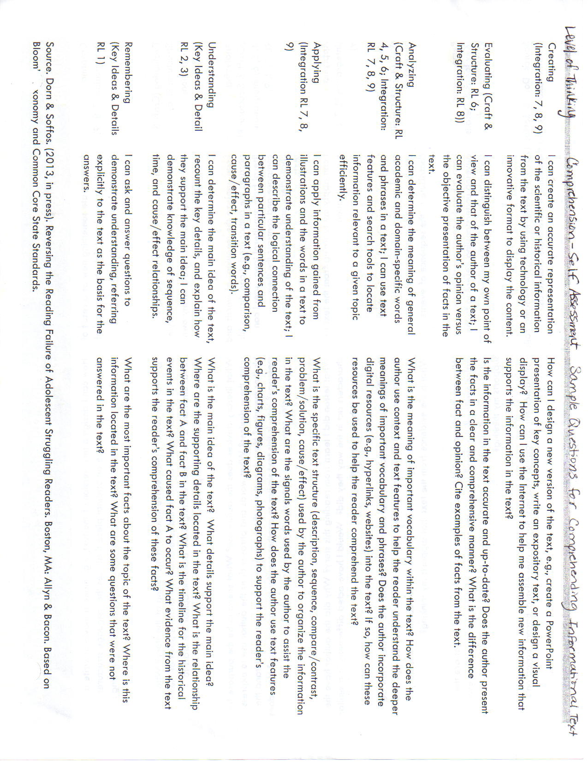

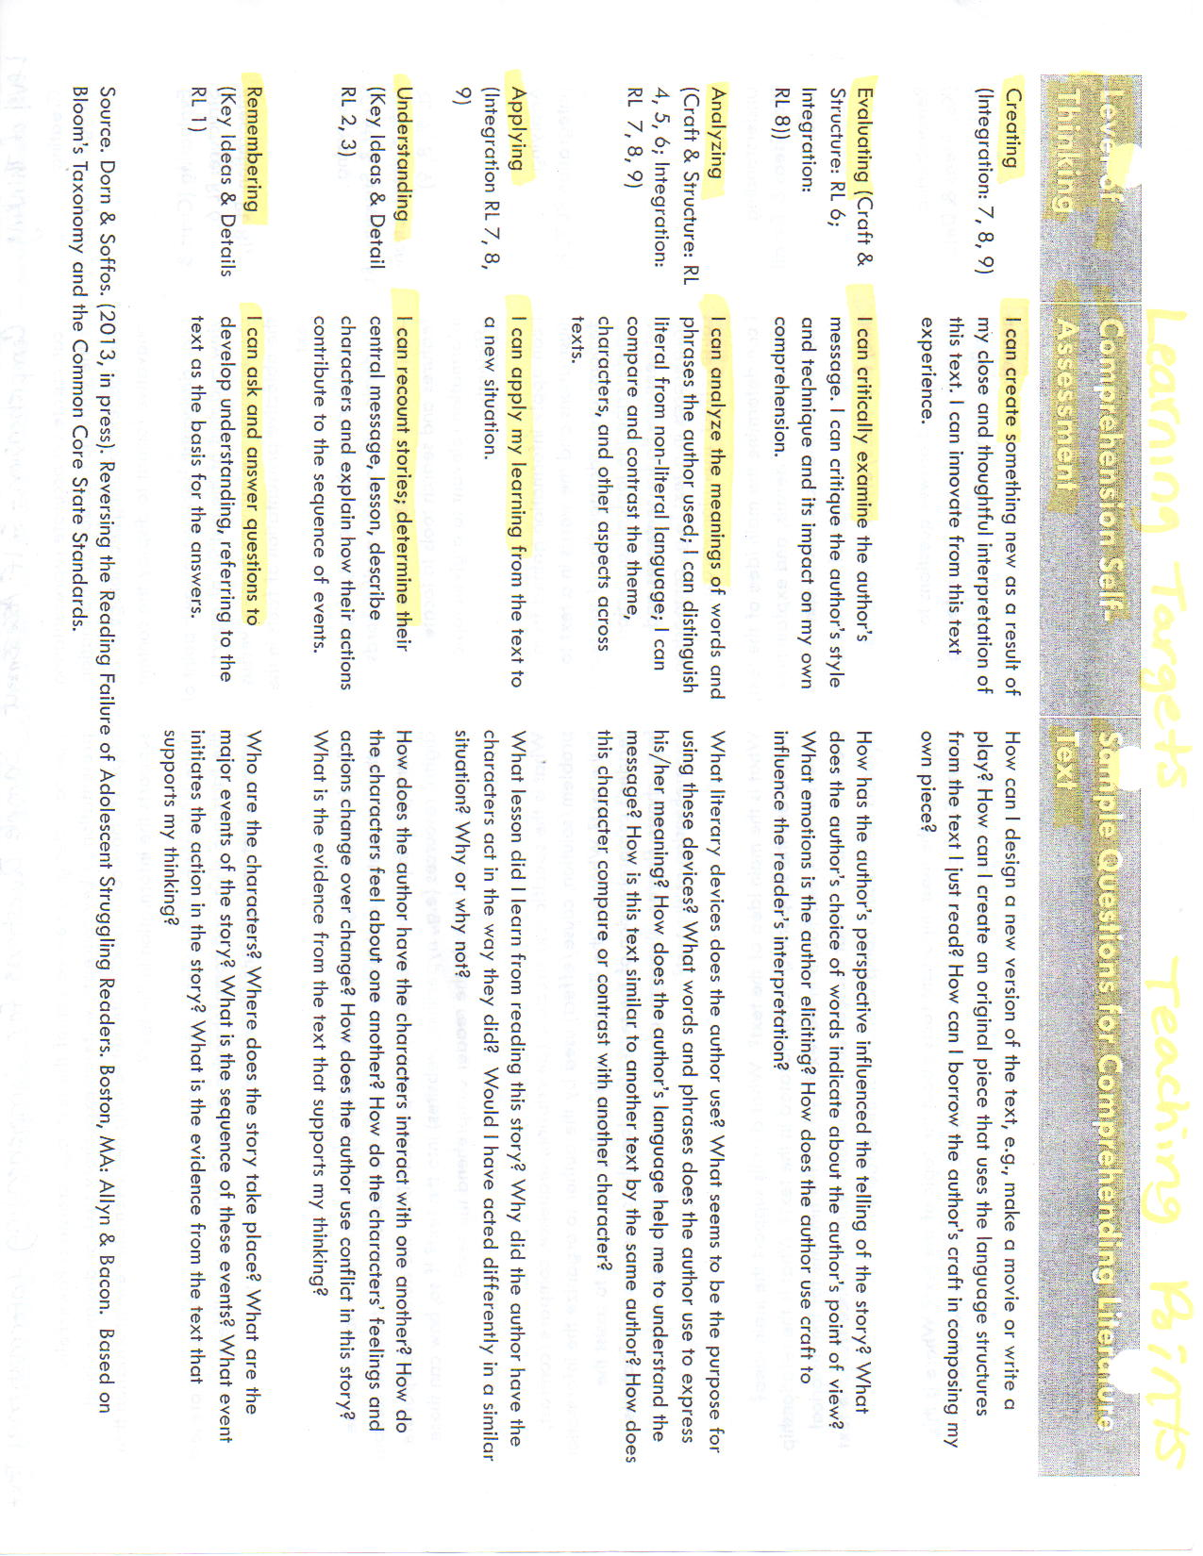

Appendix D: Conceptual Representation of Language Studies Within the PCL Model

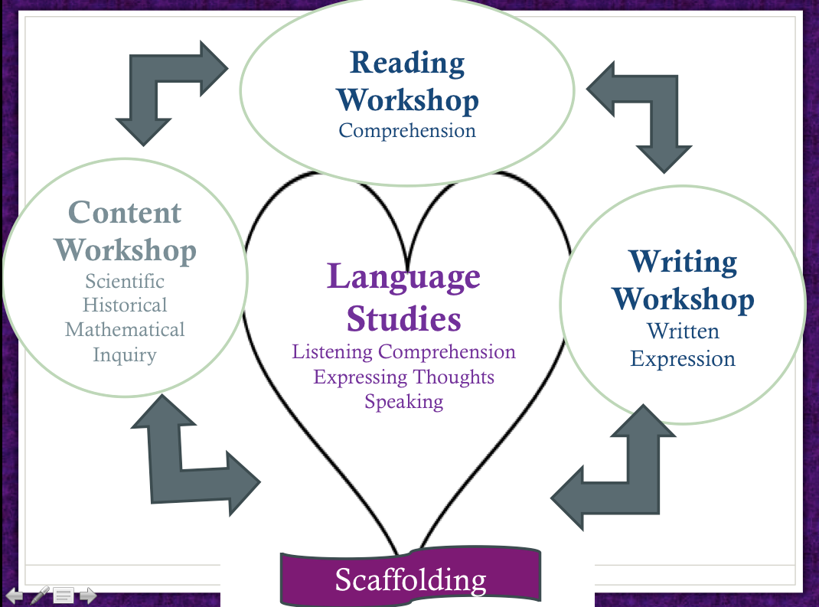

Dorn & Soffos

Appendix E: Dorn & Soffos’ Vocabulary Power Point- Key Slides (See Distance Training Session 9-13-13 for entire power point.

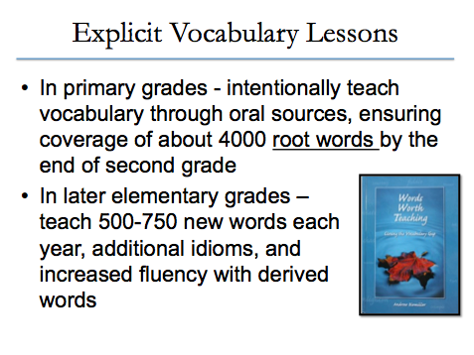

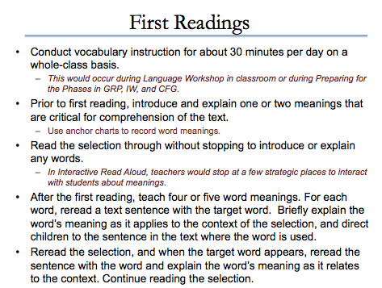

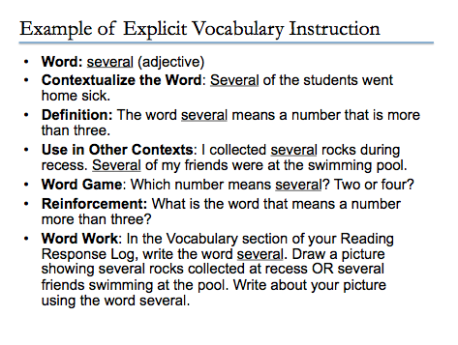

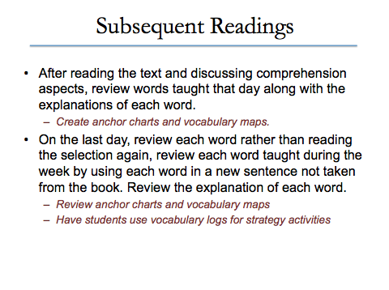

Appendix F: **Planning for Responsive Academic Vocabulary Instruction**

1. Choose/Teach Tier Two Words (academic words that cross content areas) as concepts not memorized words. See list below.
2. Use Vocabulary Acquisition Strategies:

* Context Clues

|  |  |  |  |
| --- | --- | --- | --- |
| Target word in context | This is what I think the word means | What were the clues in the sentence that helped you guess? | My new word for the target word |
| The assignment was so tedious that he started to fall asleep | Boring | Started to fall asleep | boring |

* Studying the meaning of word parts (Greek/Latin- see below)
* Developing synonyms and antonyms for the target word.

1. Teach Tier three words (content specific; specialized vocabulary such as: photosynthesis or personification) as concepts in the same way as tier 2. Know that Tier 3 words most likely do not appear on state tests.

**Teaching the Vocabulary Words**

**Step 1:** Contextualize the words. Teacher presents the term in “student-friendly” language (including descriptions, examples, and nonlinguistic representations of the term).

**Step 2:** Students restate the term in their own words (linking the new word to known experiences and background knowledge.)

**Step 3:** Students represent the term in graphic form (reinforcing and deepening understanding through processing in a second modality).

**Step 4:** Students use the term in other contexts (deepening meaning by applying the term in new situations, through writing or conversation).

**Step 5:** Students discuss the term with peers (building understanding as a class, and augmenting this knowledge with new discoveries about the word).

**Greek and Latin Roots in the Common Core State Standards:**

Root-specific standards are located in the “Foundational Skills” and “Language/Vocabulary Acquisition and Use” sections of the Common Core State Standards.

Sample standards, grade 6:

Determine or clarify meaning of unknown or multiple meaning words by… analyzing word parts (gr. 6+)

Use common, grade-appropriate Greek and Latin affixes (gr. 6+)

Using word parts, or morphological analysis, is a vocabulary acquisition strategy important for students to learn. “By separating and analyzing the meaning of a prefix, suffix, or other word root, students can often unlock the meaning of an unknown word” (Rasinski et al.)

**Tier 2 words for grades 6-8:** assume, identify, conclude, alternative, consist, contribute, define, distinct, evident, expand, indicate, individual, initial, intense, major, method, publish, structure, emphasize, illustrate, exaggerate, approximate, complicate, modify, tradition, transmit, restrict, negative, convert, analyze, consequent, impact, potential, precise

*Reference: 3-11-13 Adapted by Amend from Culturally and Linguistically Responsive Teaching and Learning* ~

Hollie & *ASCD Education Update Volume* 54: Number 11 [www.ascd.org](http://www.ascd.org) (Marzano & Pickering p. 4)