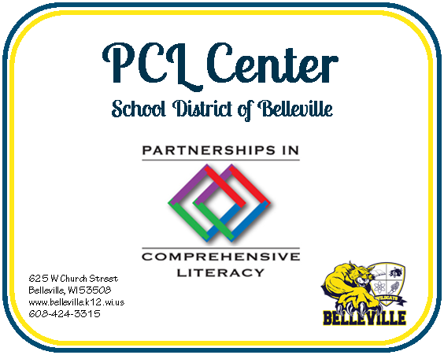
District Self-Assessment Readiness Questionnaire

Introduction: Before pursuing implementation of the Partnerships in Comprehensive Literacy (PCL) model, it is important to determine the appetite of the school district for systemic school transformation. The defining characteristic of the PCL model is that it addresses the issue of system alignment. Therefore, it is critical to garner commitment from stakeholders including: the school board of education, principals, superintendent, curriculum director, pupil services director, teachers, reading specialists and parents. Readiness for affiliation with the PCL model can be regarded as commitment placed on a continuum. Though it is not necessary that all stakeholders champion the reform, it is necessary that consensus is built. Careful attention must be paid to addressing the concerns, questions and needs of stakeholders through communication and thoughtful planning. This questionnaire is a tool that is intended to support your discernment process. At the end of the questionnaire, use the rating scale to help you assess whether or not the PCL model is a viable school transformational model for your district at this time. Then, work with the PCL staff to develop a process for tilling the soil, so to speak, by selecting or combining prototypes that help build consensus.

Directions: The questionnaire is a pulse check for readiness by teasing out the necessary conditions for moving forward with the PCL model. Circle the response that most closely aligns with the sentiment of the district. Then check where your responses cluster together on the readiness scale. On the likert scale, 1 means “not at all ready,” 5 means “it’s conceivable that we can get there” and 10 means “we’re already there.”

- The curriculum director in our district understands (or trusts the understanding of our reading specialist/s who understand) that literacy instruction is best taught through a balanced literacy approach.
We’re not ready It’s conceivable that we can We’re already there.
get there.
1……..2………3………4…………………………..5……………………..6………..7………….8………9…………10

- The curriculum director understands that student achievement is dependent upon highly skilled teachers and not on boxed programs.
We’re not ready It’s conceivable that we can We’re already there.
get there.
1……..2………3………4…………………………..5……………………..6………..7………….8………9…………10

- The curriculum director in our district understands that the gradual release of responsibility model (and/or) workshop model is an instructional approach that differentiates instruction for all learners K-12.
We’re not ready It’s conceivable that we can We’re already there.
get there.
1……..2………3………4…………………………..5……………………..6………..7………….8………9…………10

- Our district office administrative team works well together.
We’re not ready It’s conceivable that we can We’re already there.
get there.
1……..2………3………4…………………………..5……………………..6………..7………….8………9…………10

- Our pupil services director and curriculum director understand and work towards the alignment of instruction for students with IEPs and students with EL needs to universal classroom instruction.
We’re not ready It’s conceivable that we can We’re already there.
get there.
1……..2………3………4…………………………..5……………………..6………..7………….8………9…………10

- Our business manager works well with the rest of the administrative team to ensure that the allocation of resources focus on the district identified priorities.
We’re not ready It’s conceivable that we can We’re already there.
get there.
1……..2………3………4…………………………..5……………………..6………..7………….8………9…………10

- Our administrative team and school board recognize that for transformation to occur system-wide, time must be allocated for embedded professional learning for teachers and administrators.
We’re not ready It’s conceivable that we can We’re already there.
get there.
1……..2………3………4…………………………..5……………………..6………..7………….8………9…………10

- Our district administrative team recognizes that they must commit to their own professional learning.
We’re not ready It’s conceivable that we can We’re already there.
get there.
1……..2………3………4…………………………..5……………………..6………..7………….8………9…………10

- Our principals understand that transformation depends on their commitment to be lead learners in their buildings.
We’re not ready It’s conceivable that we can We’re already there.
get there.
1……..2………3………4…………………………..5……………………..6………..7………….8………9…………10

- We have one or more teachers or interventionist with a reading teacher or reading specialist certification that would be willing to go through an advanced training program and serve as a literacy coach.
We’re not ready It’s conceivable that we can We’re already there.
get there.
1……..2………3………4…………………………..5……………………..6………..7………….8………9…………10

Readiness Scale:
10 - 49 Not Ready. Consider using the PCL Center for individual services that support your district needs at this time
or work with your local CESA.

50 - 59 Getting Ready. Proceed on own with a book study, or other prototype options, or contact the PCL Center to
assist your efforts in tilling the soil.

60 – 100 Ready. The culture is ripe for moving forward. Contact the PCL Center for customized support.

